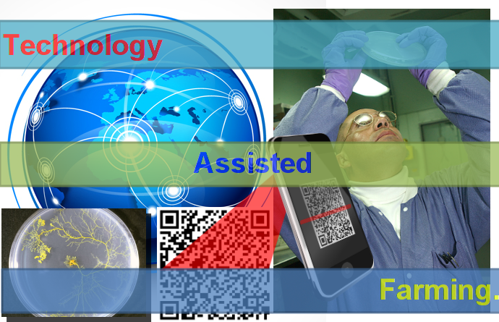

14

**ScanDisk**

**Project Idea Document**

**Shiva Prakash N and Sandeep Kumar Laik**

**A. Current Situation.**

Transformation involves multiple manual transfers, data collection, long incubation period during which regular observations are made and recorded.

As one increases the throughput and handles large number of experiments/constructs, risks of errors such as (a) losing track of events (b) mixing up of events (c) delayed transfers (d) missing to record the observations, become very high.

* + Currently, real time data entry is not possible as the place of observation (light room / laminar hood) and the dedicated place for data entry (computer) are physically removed from each other, necessitating jotting down the observations with pen and uploading the same at a later point of time.
  + Further, to look at the history of a particular experiment, one has to come to the computer and search the details. This data entry, which is not real time, contributes to the potential errors mentioned above which gets amplified when one handles large number of constructs.
  + Also, events from a large number of constructs are incubated simultaneously in the light room, each construct lying in one tray. Tracking the location of a specific tray with events from a specific construct becomes easy if one could enter the ‘tray location information’ into the system (real time), while physically placing it in the light room amongst the other hundreds of trays lying in the light room.

A system which allows data retrieval in real time and which allows data entry in real time would reduce the above risks.

**B. Goals.**

1. The goal of this project is to create a cost effective solution that allows scientists and experts working in transformation lab at MRC to capture transformation related data effortlessly minimizing the risks of error.

2. If successful, the method would be implemented across the globe in Monsanto for all transformation related activities.

3. To showcase the system as a model for real time data entry for other processes like (a) green house operation (b) media preparation (c) seed archiving (d) field observation (e) asset verification etc.

**C. Proposed Methodology.** The proposed solution utilizes the power of an android based mobile device (a smart phone), which is equipped with a camera for object detection and recognition. It also uses the QR technology for identifying the contents of each Petri plates uniquely. The complete development plan has been segregated into 3 major phases. Each followed by the approval and deployment of the phase before it.

Phase I:

In this phase we developed the android application that can scan the QR code of a Petri plate and check with the cloud database for the information’s associated to the pMON id embedded in the QR code.

In case no data was retrieved from the database the app will load the data submission screen with a pre defined template.

In case data is found in the database for the respective pMON id the app will load the data submission screen with the associated data.

User can modify and save the Petri plates and their movement related data that will be updated in the database in real time.

Use case:

1. Using the existing zebra printers we printout QR codes for individual Petri plates.
2. Each Petri plate gets it’s own QR sticker which has a 5/6 digit pMON id embedded into it.
3. To enter details regarding any new Petri plate user need to install the Barcode reader application from the given [link](http://bit.ly/scan_disk) on their android Mobile devices. The minimum android version supported by the application is Éclair [Version 2.1, API 7]. * Remember, any random QR code scanner will not work. The above mentioned app has been customized specifically for Monsanto’s use and responds exclusively to the keyword “pMON”<followed by the pMON id>. For any other purposes this app acts as a normal barcode/QR code scanner.

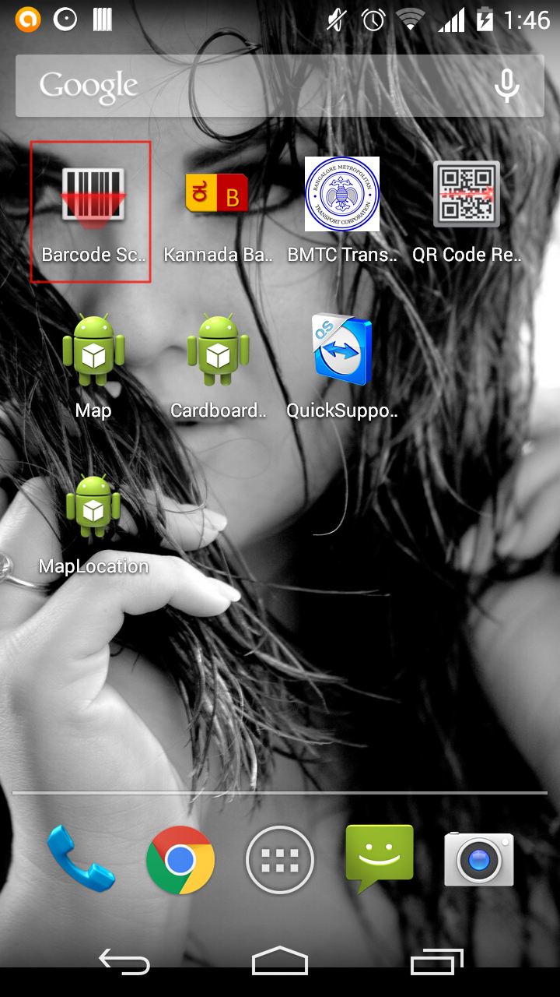

1. Once installed user can open the application.
2. Upon launch user will see a camera view with a red target line much like any common barcode scanner. User need to point and hold the target line towards the Petri plate QR code, making sure the complete QR code fits within the red line and surrounding frame.

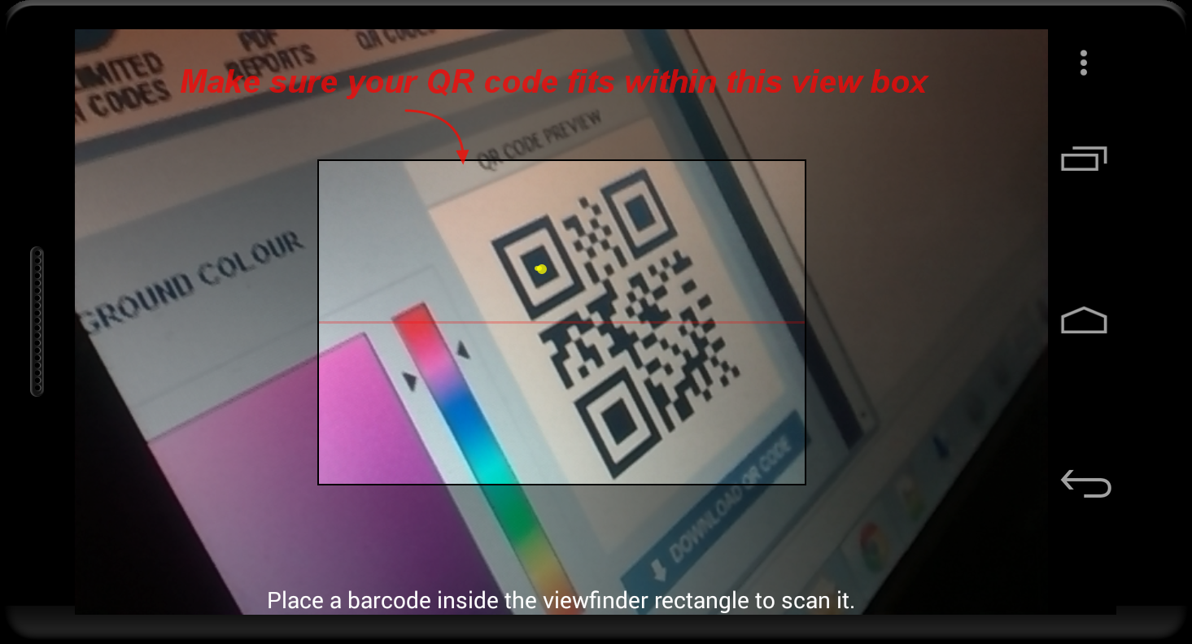

1. Upon successful detection the app will indicate the same with a beep sound. At this point the screen may freeze for a few seconds [depending on the network connection and speed], while in the backend the app will try to search for any data in the cloud database.

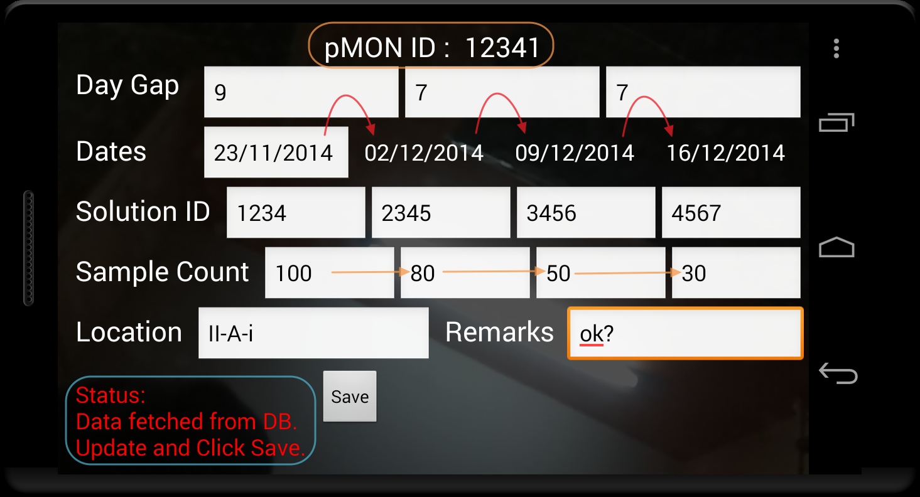

1. Based on the outcome of the search the screen will load with the new pMON id template or database data. There are 12 points of data entry at the time or writing this document. They are 3 date related gap values, first plate movement date, 4 solution/culture id values, 4 sample count values, 1 location value and 1 remarks value field. A brief about these fields functionalities are highlighted below.
   1. 3 gap values and first date value:

As per the new pMON id template the 1st date is always set to today’s date, however it’s editable. But editing the 1st date value or the 3 gap values has a ripple effect on the other 3 dates shown in the screen, which are non editable. All these 4 fields are restricted with numeric values.

It works like this:

1st plate movement date + 1st gap value(number of days) = 2nd plate movement date.

2nd plate movement date + 2nd gap value(number of days) = 3rd plate movement date.

3rd plate movement date + 3rd gap value(number of days) = 4th plate movement date.

At any point of time we can get any 4 date combination by changing the 1st date and 3 gap values.

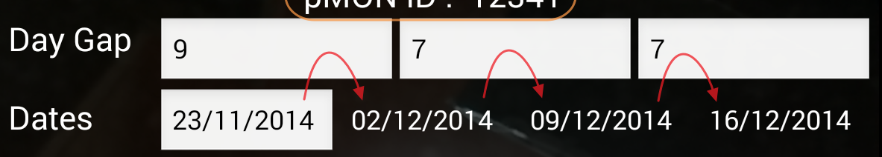

Validations:

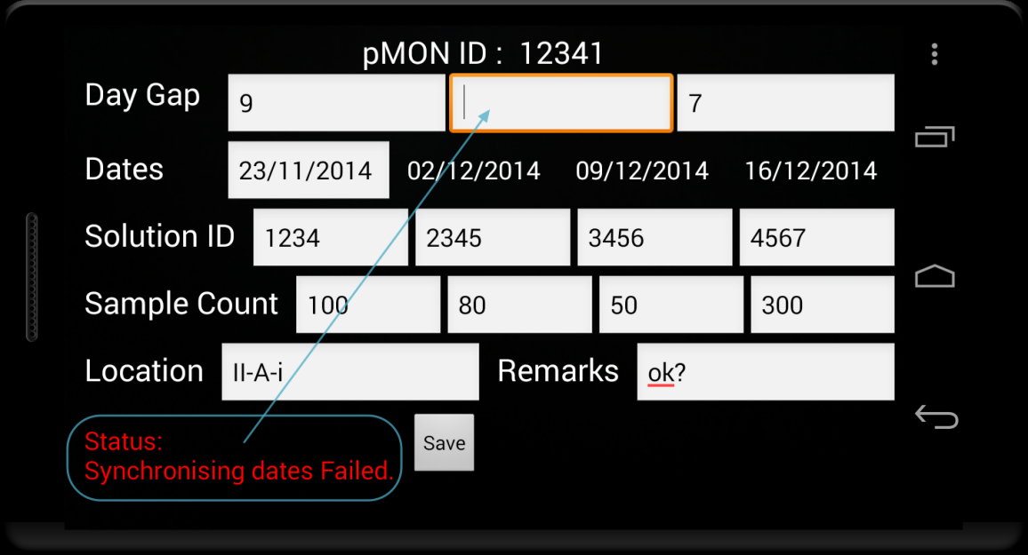

* 1. 4 media IDs: Each Petri plate has a solution or medium applied to it. This id represents the same solution/medium identifier. These 4 values are editable and have no rules to control it except that it has to be a numeric value.



Validations:

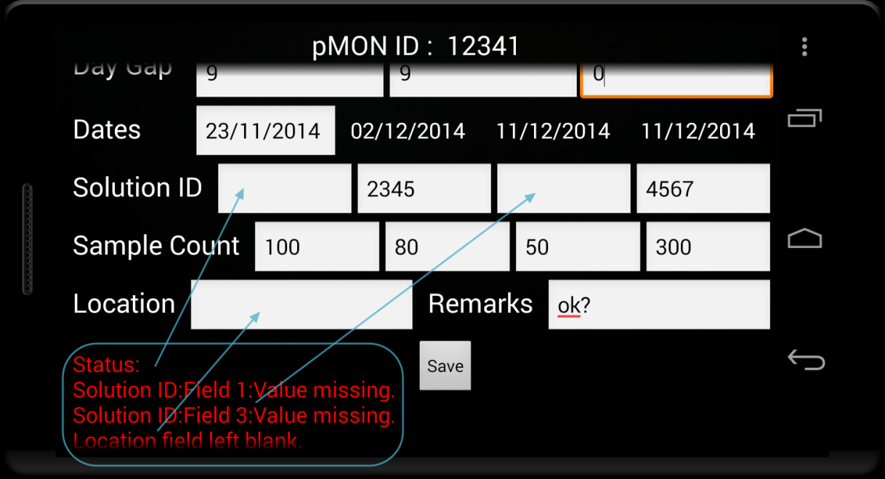

* 1. 4 “# of calli/events”: Each Petri plate sample counts are captured along with each movement. These values are restricted to be numeric and each value must be less thank or equal to the previous sample counts.



Validations:

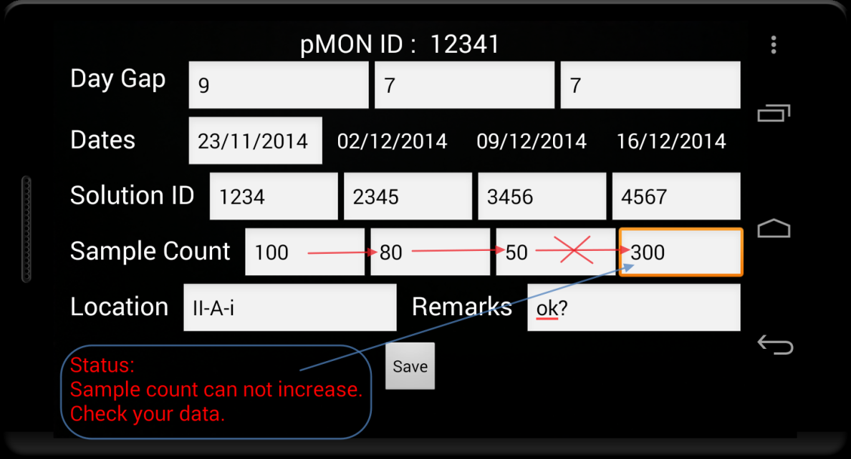

* 1. Location: This mandatory field signifies the location of the Petri plate in the lab. This field can be alphanumeric.

Validations:



* 1. Remarks: This field allows user to capture remark. This filed can be left blank and can accept multi line statement. However extensive use of special character or extremely long paragraph may break the logic or may take too much time to fetch the data. Use with caution.
  2. Others: other than all these fields we have the pMON ID at the top of the screen, a status box for information and the save button to update the information to the cloud database.

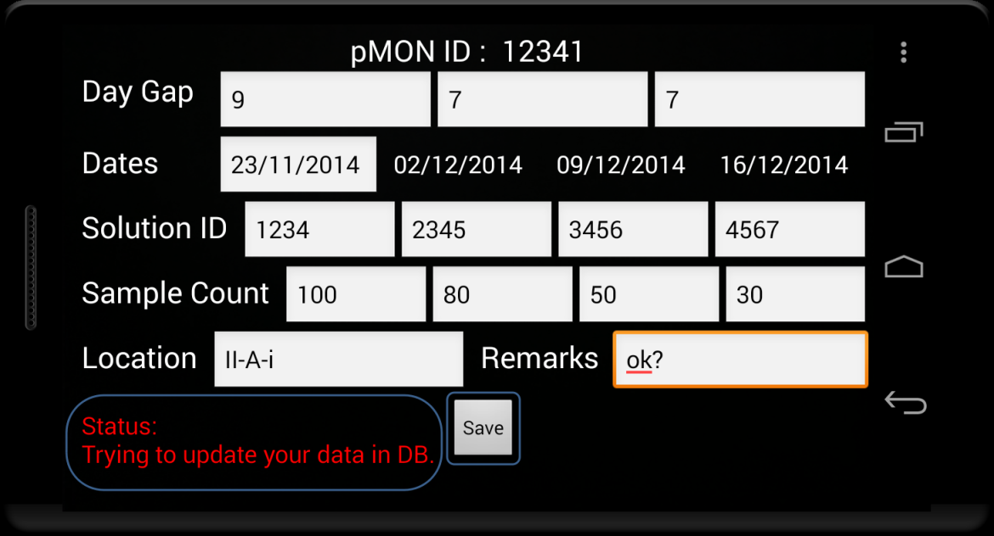

Phase II: Removal of Google spreadsheet as the cloud database and integration with Monsanto database. Also in this phase we plan to equip te application with a view to see and search through all the data.

Phase III: To provide more flexibility to the lab scientists or experts we plan to move this application to a Google cardboard framework which will provide the user a complete hands free 3d interactive and immersive experience.

**D. Time and cost.** The project has reached it’s present state within 2 weeks of analysis and development. Although till now we have worked on it only on our personal times I’m sure the development can speed up a lot more if taken up as a full time/official project.

As of now we are using android based mobile devices which is much cheaper compared to it’s IOS counterparts. We are also using Google Spreadsheet cloud services as part of the phase I, which is free. However for official purposes we strongly recommend moving the database to Monsanto servers.

**E. Qualifications.** So far on this project we have used Java, Android, Google cloud services, Google Docs API, SQL, Big Query, JSON/Parsing etc technology. Anyone working on this project will require understanding of these along with Oracle SQL/Database, VPN, connectivity, Google Cardboard Framework understanding for the future phase implementations.

**F. Benefits.**

For scaling up of transformation operations, using the industry leading cutting edge technology through the cheapest possible solution, the system offers the following advantages:

1. Saves time involved in data gathering while avoiding ‘missing data’.

2. Eliminates / drastically reduces risks of manual error in data gathering.

3. Reduces the chances of missed / delayed sub-culture

4. In conjunction with color coded labels, the system drastically reduces possibilities of mix up of events while handling of large number of transgenic plants.

**Annexure:**

1. **Solution ID, Sample count** shown in the screenshots are now specified as **Media ID, Calli/Event count** respectively.